**ISOM 3260**

**Progress Demonstration Report**

**Group 305**

|  |  |
| --- | --- |
| **Cheung Hiu Lam Emry** | **20354873** |
| **Li Hiu Ting** | **20342155** |
| **Tsui Tsz Wai** | **20341606** |
| **Lam Sin Yi** | **20384581** |
| **Pang Cheuk Ling** | **20346400** |
| **Tsue Yin Ting** | **20356792** |

**1.E-R Diagram**

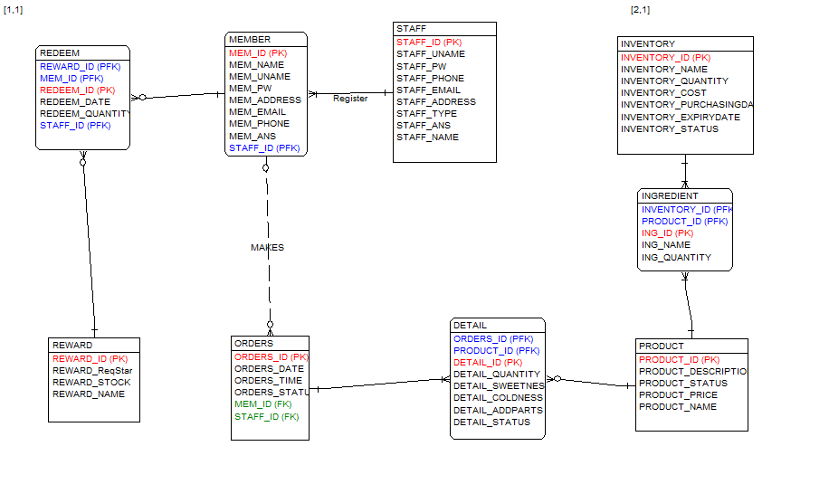



UST FRESH TEA is a tawainess drink shop. Member and staff are the two major components of its success.

Members have MEM_ID, MEM_NAME, MEM_NAME, MEM_PW, MEM_PW, MEM_ADDRESS, MEM_EMAIL, MEM_PHONE, MEM_ANS (answer for safety question).

Member can make as many orders as possible. Members can also make no orders at all. Orders have ORDER_ID, ORDER_DATE, ORDER_TIME and ODER_STATUS, and MEM_ID as of storing corresponding member who makes the order. Each order belongs to one and only one customer. Each order can contain many products, but there must be at least one product in each order. Some drinks may be unpopular among customer and thus are not added in any DETAIL or ORDERS at all.

Based on our customer loyalty strategy, each member could redeem or not redeem any reward. One redeem record belongs to one member only. REDEEM is a associate entity linking MEMBER and REWARD. REWARD stores the gift that could be redeemed by member including REWARD_ID, REWARD_ReqStar, REWARD_STOCK, REWARD_NAME. Each member could only redeem one reward each time, while populated gift could be redeemed by many member.

Each Order has at least one DETAIL, which stores the information of drink that ordered by member. Each Detail belongs to one and only one orders. DETAIL has the following attribute: DETAIL_ID, DETAIL_QUANTITY, DETAIL_SWEETNESS, DETAIL_COLDNESS, DETAIL_STATUS. EACH DETAIL belongs to one product. And, one product can belong to zero to many detail.

Product have PRODUCT_ID, PRODUCT_DESCRIPTION, PRODUCT_STATUS, PRODUCT_PRICE, PRODUCT_NAME.

INGREDIENT is stored as a separate entity to indicate each ingredients in each product, with ING_ID, ING_NAME, ING_QUANTITY. INVENTORY have the attributes of INVENTORY_ID, INVENTORY_QUANTITY, INVENTORY_COST, INVENTORY_STATUS. INGREDIENT could belong to one inventory and inventory could belong to many ingredients.

**2.Data Dictionary**

|  |  |  |  |  |  |  |
| --- | --- | --- | --- | --- | --- | --- |
| **Entity: DETAIL** | | | | | | |
| Attributes | Datatype | PK | FK | Length | NULL | Description |
| ORDERS_ID | NUMBER |  | ✓(PFK) | 20,0 | FALSE | Unique identifies order |
| PRODUCT_ID | NUMBER |  | ✓(PFK) | 20,0 | FALSE | Unique identifies product |
| DETAIL_ID | NUMBER | ✓ |  | 20,0 | FALSE | Unique identifies detail |
| DETAIL_QUANTITY | NUMBER |  |  | 10,0 | FALSE | Number of drink per detail |
| DETAIL_SWEETNESS | VARCHAR2 |  |  | 20 | TRUE | Sweetness of a drink |
| DETAIL_COLDNESS | VARCHAR2 |  |  | 20 | TRUE | Coldness of a drink |
| DETAIL_ADDPARTS | VARCHAR2 |  |  | 20 | TRUE | Extra topping of drink in a detail |
| DETAIL_STATUS | VARCHAR2 |  |  | 30 | FALSE | Production stage of drink in a detail |
| DETAIL_TEMPERATURE | VARCHAR2 |  |  | 20 | TRUE | Temperature of drink in a detail |

|  |  |  |  |  |  |  |
| --- | --- | --- | --- | --- | --- | --- |
| **Entity: INGREDIENT** | | | | | | |
| Attributes | Datatype | PK | FK | Length | NULL | Description |
| INVENTORY_ID | NUMBER |  | ✓ | 20 | FALSE | Uniquely identifies inventory |
| PRODUCT_ID | NUMBER |  | ✓ | 20 | FALSE | Uniquely identifies product |
| ING_ID | NUMBER | ✓ |  | 20 | FALSE | Uniquely identifies ingredient |
| ING_NAME | VARCHAR2 |  |  | 30 | FALSE | Quantity of a ingredient |
| ING_QUANTITY | VARCHAR2 |  |  | 10 | FALSE | Quantity of a ingredient needed for preparing a drink |

|  |  |  |  |  |  |  |
| --- | --- | --- | --- | --- | --- | --- |
| **Entity: INVENTORY** | | | | | | |
| Attributes | Datatype | PK | FK | Length | NULL | Description |
| INVENTORY_ID | NUMBER | ✓ |  | 20 | FALSE | Uniquely identifies inventory |
| INVENTORY_NAME | VARCHAR2 |  |  | 30 | FALSE | Name of inventory |
| INVENTORY_QUANTITY | NUMBER |  |  | 20 | FALSE | Quantity of inventory |
| INVENTORY_COST | NUMBER |  |  | 20,2 | TRUE | Unit cost of a inventory |
| INVENTORY_STATUS | VARCHAR2 |  |  | 20 | TRUE | Availability of inventory |

|  |  |  |  |  |  |  |
| --- | --- | --- | --- | --- | --- | --- |
| **Entity: MEMBER** | | | | | | |
| Attributes | Datatype | PK | FK | Length | NULL | Description |
| MEM_ID | NUMBER | ✓ |  | 20 | FALSE | Uniquely identifies member |
| MEM_NAME | VARCHAR2 |  |  | 30 | FALSE | Name of member |
| MEM_UNAME | VARCHAR2 |  |  | 20 | FALSE | Username of member |
| MEM_PW | VARCHAR2 |  |  | 20 | FALSE | Password |
| MEM_ADDRESS | VARCHAR2 |  |  | 100 | TRUE | Mailing address of member |
| MEM_EMAIL | VARCHAR2 |  |  | 50 | TRUE | Email of member |
| MEM_PHONE | VARCHAR2 |  |  | 20 | FALSE | Phone number of member |
| MEM_ANS | VARCHAR2 |  |  | 50 | FALSE | Answer of safety question when he forgets password |

|  |  |  |  |  |  |  |
| --- | --- | --- | --- | --- | --- | --- |
| **Entity: ORDERS** | | | | | | |
| Attributes | Datatype | PK | FK | Length | NULL | Description |
| ORDERS_ID | Number | ✓ |  | 20,0 | FALSE | Uniquely identifies order |
| ORDERS_DATE | Date |  |  | 20 | FALSE | Date when the order is placed |
| ORDERS_TIME | Timestamp with local time zone |  |  | 6 11 | FALSE | Time when the order is placed |
| ORDERS_STATUS | Varchar2 |  |  | 30 | FALSE | Show whether the order is processing/completed |
| MEM_ID | Number |  | ✓ | 20,0 | FALSE | Uniquely identifies member. It shows which member places which order. |

|  |  |  |  |  |  |  |
| --- | --- | --- | --- | --- | --- | --- |
| **Entity: PRODUCT** | | | | | | |
| Attributes | Datatype | PK | FK | Length | NULL | Description |
| PRODUCT_ID | Number | ✓ |  | 20,0 | FALSE | Uniquely identifies product |
| PRODUCT_DESCRIPTION | Varchar2 |  |  | 100 | TRUE | Brief description of each product |
| PRODUCT_STATUS | Varchar2 |  |  | 20 | TRUE | Show the availability of each product |
| PRODUCT_PRICE | Number |  |  | 5,2 | FALSE | Price of each product |
| PRODUCT_NAME | Varchar2 |  |  | 30 | FALSE | Name of each product |
| PRODUCT_TYPE | Varchar2 |  |  | 20 | FALSE | Category of the product belongs to |

|  |  |  |  |  |  |  |
| --- | --- | --- | --- | --- | --- | --- |
| **Entity: REDEEM** | | | | | | |
| Attributes | Datatype | PK | FK | Length | NULL | Description |
| REDEEM_ID | Number | ✓ |  | 20,0 | FALSE | Uniquely identifies redeem |
| MEM_ID | Number |  | ✓ | 20,0 | FALSE | Uniquely identifies member. It shows which member redeems prize |
| REWARD_ID | Number |  | ✓ | 20,0 | FALSE | Uniquely identifies reward. It shows member redeems which reward |
| REDEEM_DATE | Date |  |  |  | FALSE | It shows the redeem date |
| REDEEM_QUANTITY | Number |  |  | 10,0 | FALSE | It shows how many gifts member has redeemed |

|  |  |  |  |  |  |  |
| --- | --- | --- | --- | --- | --- | --- |
| **Entity: REWARD** | | | | | | |
| Attributes | Datatype | PK | FK | Length | NULL | Description |
| REWARD_ID | Number | ✓ |  | 20,0 | FALSE | Uniquely identifies reward |
| REWARD_ReqStar | Number |  |  | 10,0 | FALSE | It shows how many stars are required for each prize |
| REWARD_STOCK | Number |  |  | 30,0 | FALSE | It shows the quantity of available prize. |
| REWARD_NAME | Varchar2 |  |  | 20,0 | FALSE | It shows the name of the reward |

|  |  |  |  |  |  |  |
| --- | --- | --- | --- | --- | --- | --- |
| **Entity: STAFF** | | | | | | |
| Attributes | Datatype | PK | FK | Length | NULL | Description |
| STAFF_ID | Number | ✓ |  | 20 |  | Uniquely identifies staff |
| MEM_ID | Number |  | ✓ | 20 |  | Uniquely identifies which member account is register by this staff |
| STAFF_UNAME | VARCHAR2 |  |  | 50 | FALSE | Username of staff |
| STAFF_PW | Number |  |  | 38 |  | Password of staff |
| STAFF_PHONE |  |  |  | 30 |  | Phone number of staff |
| STAFF_EMAIL | VARCHAR2 |  |  | 100 |  | Email of staff |
| STAFF_ADDRESS | VARCHAR2 |  |  | 200 |  | Mailing address of staff |
| STAFF_TYPE | VARCHAR2 |  |  | 20 |  | The job position of staff |
| STAFF_ANS | VARCHAR2 |  |  | 30 |  | Answer of safety question when he forgets password |
| STAFF_NAME | VARCHAR2 |  |  | 50 | FALSE | Name of staff |

**3.Functional Requirement**

Staffs:

1. Allow staffs to login
2. Allow staffs to retrieve password
3. Allow staffs to make orders
4. Allow staffs to help customers redeem rewards
5. Allow staffs to help customers register as a member
6. Allow staffs to help customers retrieve password
7. Allow staffs to edit product lists